MODULE 1: Mobile application and its tools

1. Create “Hello World” application to display “Hello World” in the middle of the screen in red colour with white background.
XML Layout Code (activity_main.xml)
<?xml version="1.0" encoding="utf-8"?>
<LinearLayout xmlns:android="http://schemas.android.com/apk/res/android"
android:layout_width="match_parent"
android:layout_height="match_parent"
android:background="#FFFFFF" <!-- white background -->
android:gravity="center" <!-- centers the text -->
android:orientation="vertical">

<TextView
android:id="@+id/tvHello"
android:layout_width="wrap_content"
android:layout_height="wrap_content"
android:text="Hello World"
android:textColor="#FF0000" <!-- red color -->
android:textSize="28sp"
android:textStyle="bold" />

</LinearLayout>

Java Code (MainActivity.java)
package com.example.helloworldapp;

import androidx.appcompat.app.AppCompatActivity;
import android.os.Bundle;

public class MainActivity extends AppCompatActivity {
@Override
protected void onCreate(Bundle savedInstanceState) {
super.onCreate(savedInstanceState);
setContentView(R.layout.activity_main); // link to XML layout
}
}

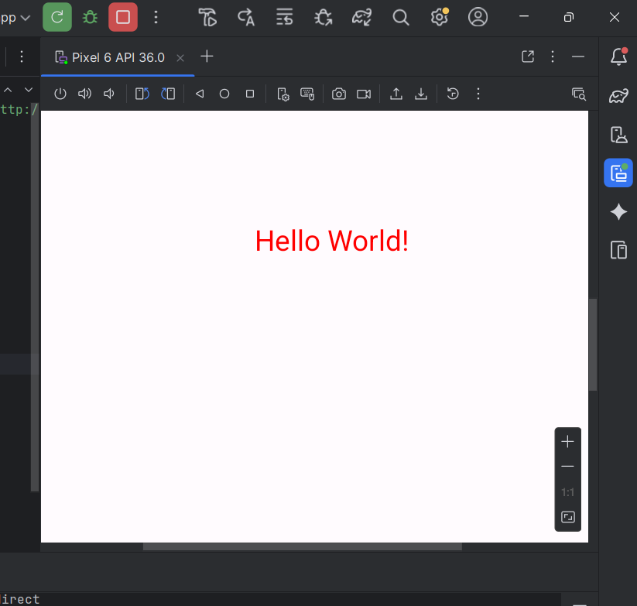

MODULE 2: Installation and configuration of Mobile application

1.Install /configure java development kit (JDK), Android studio and SDK.

Step 1: Install JDK (Java Development Kit)
Steps:
- Go to the official Oracle JDK download page: https://www.oracle.com/java/technologies/javase-downloads.html
- Download the latest version (JDK 17 or above).
- Install it using default settings.
- Set up environment variables (if not auto-set):
  - Go to Control Panel → System → Advanced System Settings → Environment Variables
  - Under System Variables, click New
Variable Name: JAVA_HOME
Variable Value: C:\Program Files\Java\jdk-17
  - Add %JAVA_HOME%\bin to Path.
Step 2: Install Android Studio
Purpose:
Android Studio is the official IDE for Android app development.
Steps:
- Download from:
https://developer.android.com/studio
- Run the installer (.exe file).
- During setup, make sure Android SDK, Android Virtual Device (AVD), and Android SDK Platform Tools are checked.
- Choose installation location and click Next → Finish.
After installation:
Launch Android Studio → It will automatically download required components.

Step 3: Configure Android SDK
Steps:
- Open Android Studio → Settings → Appearance & Behavior → System Settings → Android SDK
- Select the latest SDK Platform (e.g., Android 14 or 15).
- Select SDK Tools tab → check:
  - Android SDK Build-Tools
  - Android Emulator
  - Android SDK Platform-Tools
  - Android SDK Tools
- Click Apply → OK.
The SDK will now be downloaded and configured.
2. Configure Development Tools (ADT Plug-in) and Create Virtual Device
Step 4: Configure ADT (Android Development Tools) Plug-in
If you’re using Android Studio, you already have:
- Android SDK Manager
- AVD Manager
- Logcat, Layout Editor, etc.
Step 5: Create Virtual Device (AVD – Android Emulator)
Steps:
- Open Android Studio → Tools → Device Manager
- Click on Create Device
- Choose a hardware device (e.g., Pixel 7)
- Select a System Image (e.g., Android 13 or 14)
- Click Next, name your device (e.g., “MyVirtualDevice”)
- Click Finish

MODULE 3: UI Components and Layouts

- Create an application to design a Visiting Card. The Visiting card should have a company logo at the top right corner. The company name should be displayed in Capital letters, aligned to the center. Information like the name of the employee, job title, phone number, address, email, fax and the website address is to be displayed. Insert a horizontal line between the job title and the phone number.
XML Layout Code (activity_main.xml)

<?xml version="1.0" encoding="utf-8"?>
<LinearLayout xmlns:android="http://schemas.android.com/apk/res/android"
android:layout_width="match_parent"
android:layout_height="wrap_content"
android:orientation="vertical"
android:padding="16dp"
android:background="#FFF8E1">
<!-- Company logo at top-right -->
<RelativeLayout
android:layout_width="match_parent"
android:layout_height="wrap_content">
<ImageView
android:id="@+id/companyLogo"
android:layout_width="80dp"
android:layout_height="80dp"
android:layout_alignParentEnd="true" android:src="@drawable/company_logo"
android:contentDescription="Company Logo" />
<TextView
android:id="@+id/companyName"
android:layout_width="wrap_content"
android:layout_height="wrap_content"
android:layout_centerHorizontal="true"
android:text="TECHNOVIBE SOLUTIONS"
android:textStyle="bold"
android:textSize="22sp"
android:textColor="#000000"
android:textAllCaps="true"
android:paddingTop="20dp" />
</RelativeLayout>
<!-- Employee Info Section -->
<TextView
android:id="@+id/employeeName"
android:layout_width="wrap_content"
android:layout_height="wrap_content"
android:text="Komal Thakare"
android:textSize="18sp"
android:textStyle="bold"
android:paddingTop="16dp" />
<TextView
android:id="@+id/jobTitle"
android:layout_width="wrap_content"
android:layout_height="wrap_content"
android:text="Software Engineer"
android:textSize="16sp"
android:textColor="#555555" />
<!-- Horizontal Line -->
<View
android:layout_width="match_parent"
android:layout_height="1dp"
android:background="#000000"
android:layout_marginVertical="8dp" />
<!-- Contact Details -->
<TextView
android:layout_width="wrap_content"
android:layout_height="wrap_content"
android:text="📞 +91 9876543210"
android:textSize="14sp" />
<TextView
android:layout_width="wrap_content"
android:layout_height="wrap_content"
android:text="🏠 123, Pune, Maharashtra"
android:textSize="14sp" />
<TextView
android:layout_width="wrap_content"
android:layout_height="wrap_content"
android:text="✉️ komal.thakare@technovibe.com"
android:textSize="14sp" />
<TextView
android:layout_width="wrap_content"
android:layout_height="wrap_content"
android:text="📠 Fax: +91 2023456789"
android:textSize="14sp" />
<TextView
android:layout_width="wrap_content"
android:layout_height="wrap_content"
android:text="🌐 www.technovibe.com"
android:textSize="14sp" />

</LinearLayout>

- Implement Linear and Absolute Layout Scenario: You’re designing an app where the login form needs to display username and password fields stacked vertically. You use LinearLayout for this simple vertical arrangement. Additionally, a separate section of the app requires precise control over the placement of some icons, so you use AbsoluteLayout for that section.

XML Code:
<?xml version="1.0" encoding="utf-8"?>
<ScrollView xmlns:android="http://schemas.android.com/apk/res/android"
android:layout_width="match_parent"
android:layout_height="match_parent">
<LinearLayout
android:layout_width="match_parent"
android:layout_height="wrap_content"
android:orientation="vertical"
android:padding="16dp"
android:gravity="center_horizontal"
android:background="#E3F2FD">
<TextView
android:layout_width="wrap_content"
android:layout_height="wrap_content"
android:text="Login Form"
android:textStyle="bold"
android:textSize="20sp"
android:layout_marginBottom="12dp" />
<EditText
android:id="@+id/username"
android:layout_width="match_parent"
android:layout_height="wrap_content"
android:hint="Enter Username"
android:inputType="textPersonName"
android:layout_marginBottom="8dp" />
<EditText
android:id="@+id/password"
android:layout_width="match_parent"
android:layout_height="wrap_content"
android:hint="Enter Password"
android:inputType="textPassword"
android:layout_marginBottom="12dp" />
<Button
android:id="@+id/btnLogin"
android:layout_width="wrap_content"
android:layout_height="wrap_content"
android:text="Login" />
<View
android:layout_width="match_parent"
android:layout_height="2dp"
android:background="#000000"
android:layout_marginVertical="16dp" />
<TextView
android:layout_width="wrap_content"
android:layout_height="wrap_content"
android:text="Icons Section (AbsoluteLayout)"
android:textStyle="bold"
android:textSize="16sp"
android:layout_marginBottom="8dp" />
<AbsoluteLayout
android:layout_width="match_parent"
android:layout_height="200dp"
android:background="#FFF3E0">
<ImageView
android:layout_width="60dp"
android:layout_height="60dp"
android:layout_x="40dp"
android:layout_y="20dp"
android:src="@drawable/ic_home"
android:contentDescription="Home Icon" />
<ImageView
android:layout_width="60dp"
android:layout_height="60dp"
android:layout_x="150dp"
android:layout_y="100dp"
android:src="@drawable/ic_settings"
android:contentDescription="Settings Icon" />
<ImageView
android:layout_width="60dp"
android:layout_height="60dp"
android:layout_x="250dp"
android:layout_y="40dp"
android:src="@drawable/ic_user"
android:contentDescription="User Icon" />
</AbsoluteLayout>
</LinearLayout>

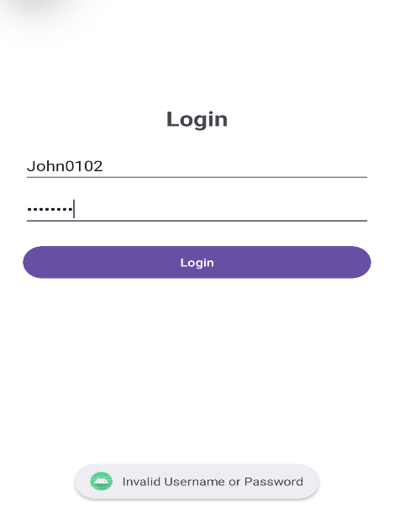

- Implement Frame, Table, and Relative Layouts Scenario: For a weather app, you need to create a layout with a header at the top, a content section with multiple elements arranged in a table (e.g., hourly forecast), and a floating button. You use FrameLayout to stack elements like the floating button over the content, TableLayout to arrange forecast data in rows, and RelativeLayout to position the header relative to the content.
XML Code (activity_main.xml)

<?xml version="1.0" encoding="utf-8"?>
<FrameLayout xmlns:android="http://schemas.android.com/apk/res/android"
android:layout_width="match_parent"
android:layout_height="match_parent"
android:background="#E3F2FD">

<!-- Header Section (RelativeLayout) -->
<RelativeLayout
android:id="@+id/headerLayout"
android:layout_width="match_parent"
android:layout_height="wrap_content"
android:padding="16dp"
android:background="#2196F3">
<TextView
android:id="@+id/appTitle"
android:layout_width="wrap_content"
android:layout_height="wrap_content"
android:text="WEATHER FORECAST"
android:textColor="#FFFFFF"
android:textStyle="bold"
android:textSize="20sp"
android:layout_centerHorizontal="true" />
<ImageView
android:id="@+id/weatherIcon"
android:layout_width="40dp"
android:layout_height="40dp"
android:src="@drawable/ic_sun"
android:layout_alignParentEnd="true"
android:contentDescription="Weather Icon" />
</RelativeLayout>
<ScrollView
android:layout_width="match_parent"
android:layout_height="match_parent"
android:layout_marginTop="80dp"
android:padding="16dp">
<TableLayout
android:id="@+id/tableLayout"
android:layout_width="match_parent"
android:layout_height="wrap_content"
android:stretchColumns="1">
<TableRow>
<TextView
android:text="Time"
android:textStyle="bold"
android:textSize="16sp"
android:padding="8dp" />
<TextView
android:text="Temperature"
android:textStyle="bold"
android:textSize="16sp"
android:padding="8dp" />
<TextView
android:text="Condition"
android:textStyle="bold"
android:textSize="16sp"
android:padding="8dp" />
</TableRow>
<TableRow>
<TextView android:text="08:00 AM" android:padding="8dp" />
<TextView android:text="25°C" android:padding="8dp" />
<TextView android:text="Sunny" android:padding="8dp" />
</TableRow>
<TableRow>
<TextView android:text="12:00 PM" android:padding="8dp" />
<TextView android:text="30°C" android:padding="8dp" />
<TextView android:text="Clear Sky" android:padding="8dp" />
</TableRow>
<TableRow>
<TextView android:text="04:00 PM" android:padding="8dp" />
<TextView android:text="28°C" android:padding="8dp" />
<TextView android:text="Partly Cloudy" android:padding="8dp" />
</TableRow>
<TableRow>
<TextView android:text="08:00 PM" android:padding="8dp" />
<TextView android:text="22°C" android:padding="8dp" />
<TextView android:text="Cool Breeze" android:padding="8dp" />
</TableRow>
</TableLayout>
</ScrollView>
<ImageButton
android:id="@+id/btnRefresh"
android:layout_width="60dp"
android:layout_height="60dp"
android:src="@drawable/ic_refresh"
android:backgroundTint="#FFEB3B"
android:background="@drawable/round_button"
android:layout_gravity="bottom|end"
android:layout_margin="20dp"
android:contentDescription="Refresh" />
</FrameLayout>

Java code:
package com.example.m1qi;

import androidx.appcompat.app.AppCompatActivity;
import android.os.Bundle;
import android.widget.Button;
import android.widget.Toast;
import android.view.View;

public class MainActivity extends AppCompatActivity {

Button btnRefresh;

@Override
protected void onCreate(Bundle savedInstanceState) {
super.onCreate(savedInstanceState);
setContentView(R.layout.activity_main);

btnRefresh = findViewById(R.id.btnRefresh);

btnRefresh.setOnClickListener(new View.OnClickListener() {
@Override
public void onClick(View view) {
Toast.makeText(MainActivity.this, "Weather Updated!", Toast.LENGTH_SHORT).show();
}
});
}
}

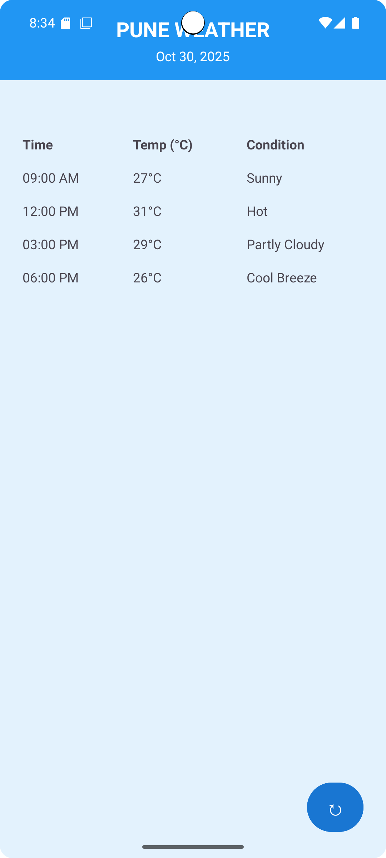

- Create a screen that has input boxes for User Name, Password, Address, Gender(radio buttons for male and female), Age (numeric), Date of Birth (Date Picket), State (Spinner) and a Submit button. On clicking the submit button, print all the data below the Submit Button (use any layout)
XML Layout Code (activity_main.xml)

<?xml version="1.0" encoding="utf-8"?>
<ScrollView xmlns:android="http://schemas.android.com/apk/res/android"
android:layout_width="match_parent"
android:layout_height="match_parent"
android:padding="16dp"
android:background="#E3F2FD">
<LinearLayout
android:layout_width="match_parent"
android:layout_height="wrap_content"
android:orientation="vertical"
android:gravity="center_horizontal">
<TextView
android:layout_width="wrap_content"
android:layout_height="wrap_content"
android:text="User Registration Form"
android:textStyle="bold"
android:textSize="22sp"
android:layout_marginBottom="20dp" />
<EditText
android:id="@+id/etName"
android:layout_width="match_parent"
android:layout_height="wrap_content"
android:hint="Enter Name"
android:inputType="textPersonName"
android:layout_marginBottom="10dp" />
<EditText
android:id="@+id/etPassword"
android:layout_width="match_parent"
android:layout_height="wrap_content"
android:hint="Enter Password"
android:inputType="textPassword"
android:layout_marginBottom="10dp" />
<EditText
android:id="@+id/etAddress"
android:layout_width="match_parent"
android:layout_height="wrap_content"
android:hint="Enter Address"
android:inputType="textPostalAddress"
android:layout_marginBottom="10dp" />
<TextView
android:layout_width="wrap_content"
android:layout_height="wrap_content"
android:text="Select Gender:"
android:textStyle="bold"
android:layout_marginTop="10dp" />
<RadioGroup
android:id="@+id/radioGender"
android:layout_width="wrap_content"
android:layout_height="wrap_content"
android:orientation="horizontal">
<RadioButton
android:id="@+id/rbMale"
android:layout_width="wrap_content"
android:layout_height="wrap_content"
android:text="Male" />
<RadioButton
android:id="@+id/rbFemale"
android:layout_width="wrap_content"
android:layout_height="wrap_content"
android:text="Female" />
</RadioGroup>
<EditText
android:id="@+id/etAge"
android:layout_width="match_parent"
android:layout_height="wrap_content"
android:hint="Enter Age"
android:inputType="number"
android:layout_marginBottom="10dp" />
<TextView
android:layout_width="wrap_content"
android:layout_height="wrap_content"
android:text="Date of Birth:"
android:textStyle="bold"
android:layout_marginTop="10dp" />
<DatePicker
android:id="@+id/datePicker"
android:layout_width="match_parent"
android:layout_height="wrap_content" />
<TextView
android:layout_width="wrap_content"
android:layout_height="wrap_content"
android:text="Select State:"
android:textStyle="bold"
android:layout_marginTop="10dp" />
<Spinner
android:id="@+id/spinnerState"
android:layout_width="match_parent"
android:layout_height="wrap_content"
android:layout_marginBottom="16dp" />
<Button
android:id="@+id/btnSubmit"
android:layout_width="wrap_content"
android:layout_height="wrap_content"
android:text="Submit"
android:layout_marginTop="12dp" />
<TextView
android:id="@+id/tvResult"
android:layout_width="match_parent"
android:layout_height="wrap_content"
android:textSize="16sp"
android:paddingTop="20dp"
android:textColor="#000000" />
</LinearLayout>
</ScrollView>

Java Code (MainActivity.java)
package com.example.userform;
import android.os.Bundle;
import android.view.View;
import android.widget.*;
import androidx.appcompat.app.AppCompatActivity;
public class MainActivity extends AppCompatActivity {
EditText etName, etPassword, etAddress, etAge;
RadioGroup radioGender;
Spinner spinnerState;
DatePicker datePicker;
Button btnSubmit;
TextView tvResult;
@Override
protected void onCreate(Bundle savedInstanceState) {
super.onCreate(savedInstanceState);
setContentView(R.layout.activity_main);
etName = findViewById(R.id.etName);
etPassword = findViewById(R.id.etPassword);
etAddress = findViewById(R.id.etAddress);
etAge = findViewById(R.id.etAge);
radioGender = findViewById(R.id.radioGender);
spinnerState = findViewById(R.id.spinnerState);
datePicker = findViewById(R.id.datePicker);
btnSubmit = findViewById(R.id.btnSubmit);
tvResult = findViewById(R.id.tvResult);

String [] states = {"Maharashtra", "Gujarat", "Karnataka", "Delhi", "Tamil Nadu"};
ArrayAdapter<String> adapter = new ArrayAdapter<>(this, android.R.layout.simple_spinner_dropdown_item, states);
spinnerState.setAdapter(adapter);
btnSubmit.setOnClickListener(v -> {
String name = etName.getText().toString();
String pass = etPassword.getText().toString();
String addr = etAddress.getText().toString();
String age = etAge.getText().toString();
int selectedId = radioGender.getCheckedRadioButtonId();
RadioButton selectedGender = findViewById(selectedId);
String gender = selectedGender != null ? selectedGender.getText().toString() : "Not Selected";
String state = spinnerState.getSelectedItem().toString();
int day = datePicker.getDayOfMonth();
int month = datePicker.getMonth() + 1;
int year = datePicker.getYear();
String dob = day + "/" + month + "/" + year;
String result = "Name: " + name +
"\nPassword: " + pass +
"\nAddress: " + addr +
"\nGender: " + gender +
"\nAge: " + age +
"\nDOB: " + dob +
"\nState: " + state;
tvResult.setText(result);
});
}
}

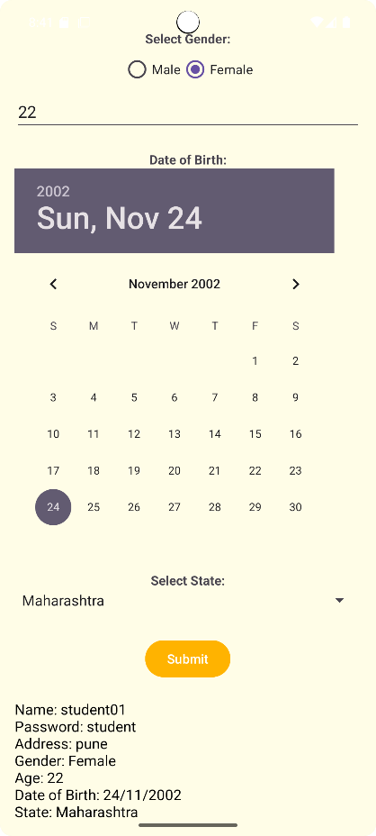

MODULE 4: Designing User Interface with View

- Create sample application with login module. (Check username and password), validate it for login screen or alert the user with a Toast.

(activity_main.xml)
<?xml version="1.0" encoding="utf-8"?>
<LinearLayout xmlns:android="http://schemas.android.com/apk/res/android"
android:layout_width="match_parent"
android:layout_height="match_parent"
android:orientation="vertical"
android:padding="24dp"
android:gravity="center"
android:background="#FFFFFF">
<TextView
android:text="Login"
android:textSize="26sp"
android:textStyle="bold"
android:layout_marginBottom="20dp"
android:gravity="center"
android:layout_width="wrap_content"
android:layout_height="wrap_content"/>
<EditText
android:id="@+id/etUsername"
android:hint="Enter Username"
android:layout_width="match_parent"
android:layout_height="wrap_content" />
<EditText
android:id="@+id/etPassword"
android:hint="Enter Password"
android:inputType="textPassword"
android:layout_width="match_parent"
android:layout_height="wrap_content"
android:layout_marginTop="10dp" />
<Button
android:id="@+id/btnLogin"
android:text="Login"
android:layout_width="match_parent"
android:layout_height="wrap_content"
android:layout_marginTop="20dp" />
</LinearLayout>

(MainActivity.java)
package com.example.loginmodule;
import androidx.appcompat.app.AppCompatActivity;
import android.os.Bundle;
import android.view.View;
import android.widget.*;
public class MainActivity extends AppCompatActivity {
EditText etUsername, etPassword;
Button btnLogin;
@Override
protected void onCreate(Bundle savedInstanceState) {
super.onCreate(savedInstanceState);
setContentView(R.layout.activity_main);
etUsername = findViewById(R.id.etUsername);
etPassword = findViewById(R.id.etPassword);
btnLogin = findViewById(R.id.btnLogin);
btnLogin.setOnClickListener(new View.OnClickListener() {
@Override
public void onClick(View v) {
String user = etUsername.getText().toString();
String pass = etPassword.getText().toString();
if (user.equals("admin") && pass.equals("1234")) {
Toast.makeText(MainActivity.this, "Login Successful", Toast.LENGTH_SHORT).show();
} else {
Toast.makeText(MainActivity.this, "Invalid Username or Password", Toast.LENGTH_SHORT).show();
} } }); } }

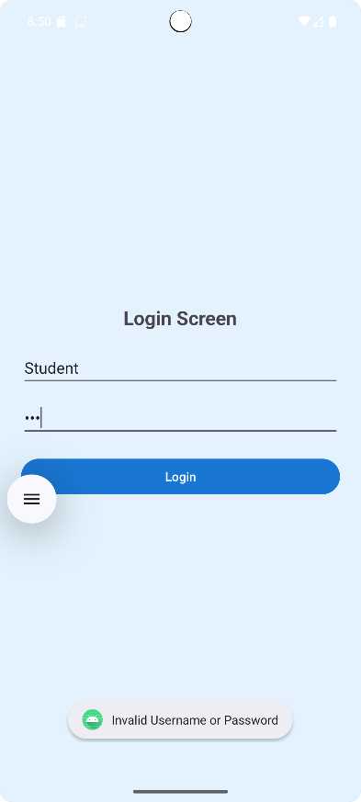

- Create an application to design a Visiting Card. The Visiting card should have a company logo at the top right corner. The company name should be displayed in Capital letters, aligned to the center. Information like the name of the employee, job title, phone number, address, email, fax and the website address is to be displayed. Insert a horizontal line between the job title and the phone number
<?xml version="1.0" encoding="utf-8"?>
<LinearLayout xmlns:android="http://schemas.android.com/apk/res/android"
android:layout_width="match_parent"
android:layout_height="match_parent"
android:orientation="vertical"
android:padding="20dp"
android:background="#FFFFFF">
<RelativeLayout
android:layout_width="match_parent"
android:layout_height="wrap_content"
android:layout_marginBottom="15dp">
<TextView
android:id="@+id/tvCompany"
android:layout_width="wrap_content"
android:layout_height="wrap_content"
android:text="TECH INNOVATORS PVT. LTD."
android:textStyle="bold"
android:textAllCaps="true"
android:textSize="20sp"
android:layout_centerHorizontal="true"
android:textColor="#000000" />
<ImageView
android:id="@+id/imgLogo"
android:layout_width="60dp"
android:layout_height="60dp"
android:src="@drawable/ic_launcher_foreground"
android:layout_alignParentRight="true" />
</RelativeLayout>
<TextView
android:id="@+id/tvName"
android:layout_width="wrap_content"
android:layout_height="wrap_content"
android:text="Komal Thakare"
android:textSize="18sp"
android:textStyle="bold"
android:textColor="#E91E63" />
<TextView
android:id="@+id/tvJob"
android:layout_width="wrap_content"
android:layout_height="wrap_content"
android:text="Software Engineer"
android:textColor="#333333"
android:layout_marginBottom="8dp" />
<View
android:layout_width="match_parent"
android:layout_height="1dp"
android:background="#000000"
android:layout_marginBottom="8dp" />
<TextView
android:text="Phone: +91 9876543210"
android:layout_width="wrap_content"
android:layout_height="wrap_content"
android:layout_marginBottom="4dp" />
<TextView
android:text="Email: komal.thakare@techinnovators.com"
android:layout_width="wrap_content"
android:layout_height="wrap_content"
android:layout_marginBottom="4dp" />
<TextView
android:text="Address: 101, IT Park, Nagpur"
android:layout_width="wrap_content"
android:layout_height="wrap_content"
android:layout_marginBottom="4dp" />
<TextView
android:text="Fax: +91 9876543211"
android:layout_width="wrap_content"
android:layout_height="wrap_content"
android:layout_marginBottom="4dp" />
<TextView
android:text="Website: www.techinnovators.com"
android:layout_width="wrap_content"
android:layout_height="wrap_content"
android:textColor="#1565C0" />
</LinearLayout>

(MainActivity.java)
package com.example.visitingcard;
import androidx.appcompat.app.AppCompatActivity;
import android.os.Bundle;
public class MainActivity extends AppCompatActivity {
@Override
protected void onCreate(Bundle savedInstanceState) {
super.onCreate(savedInstanceState);
setContentView(R.layout.activity_main);
}
}

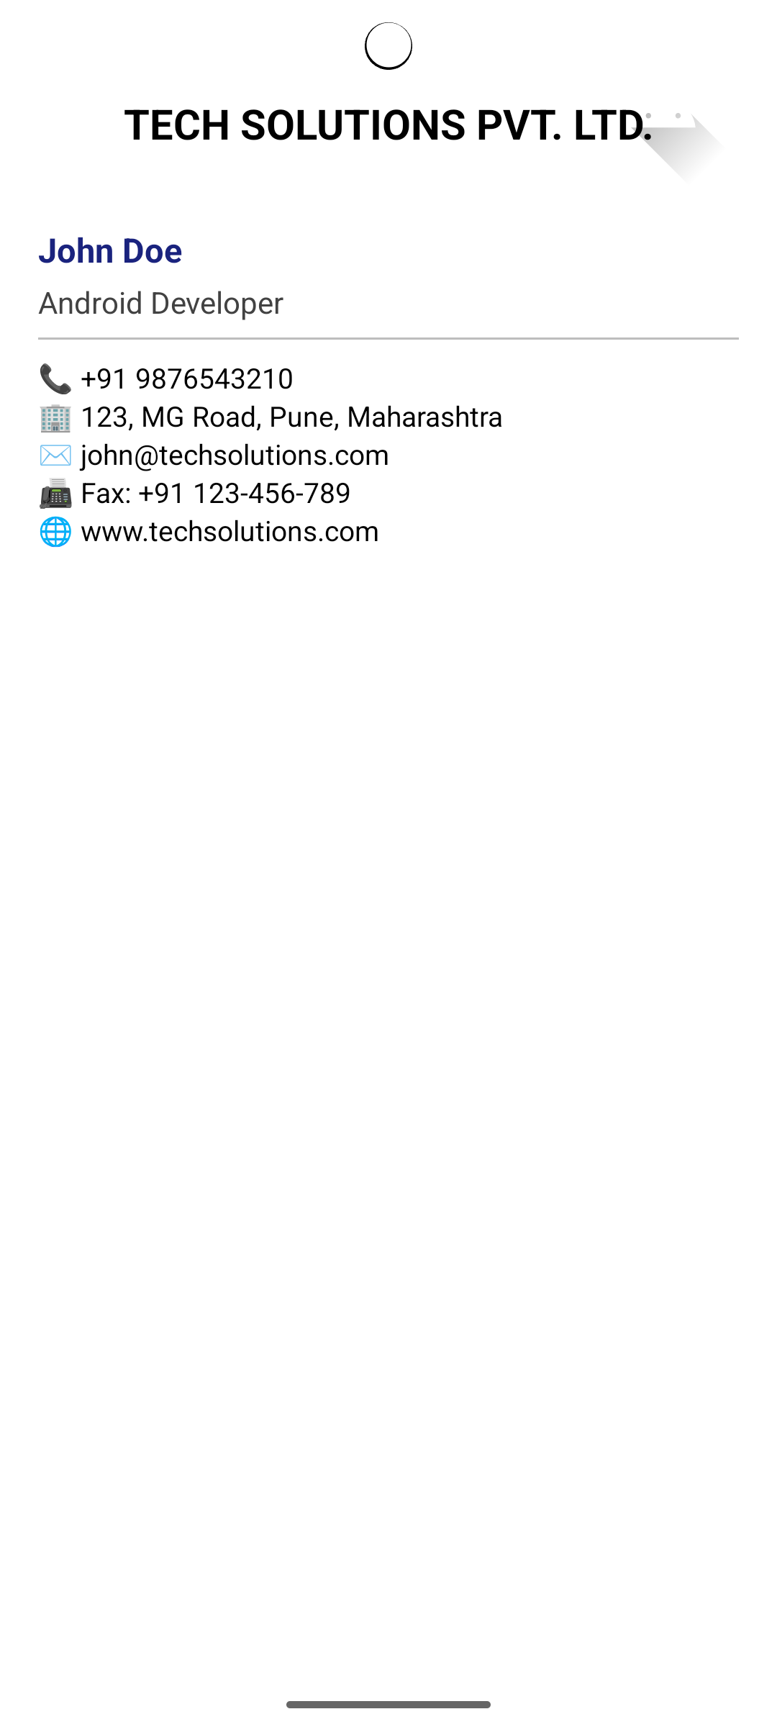

- Develop an application using controls like Button, TextView, EditText for designing a calculator

XML (activity_main.xml)
<?xml version="1.0" encoding="utf-8"?>
<LinearLayout xmlns:android="http://schemas.android.com/apk/res/android"
android:layout_width="match_parent"
android:layout_height="match_parent"
android:orientation="vertical"
android:padding="24dp"
android:gravity="center">
<EditText
android:id="@+id/etNum1"
android:hint="Enter Number 1"
android:inputType="numberDecimal"
android:layout_width="match_parent"
android:layout_height="wrap_content"/>
<EditText
android:id="@+id/etNum2"
android:hint="Enter Number 2"
android:inputType="numberDecimal"
android:layout_width="match_parent"
android:layout_height="wrap_content"
android:layout_marginTop="10dp"/>
<TextView
android:id="@+id/tvResult"
android:text="Result:"
android:textSize="20sp"
android:layout_marginTop="20dp"
android:layout_width="wrap_content"
android:layout_height="wrap_content"/>
<LinearLayout
android:orientation="horizontal"
android:layout_width="match_parent"
android:layout_height="wrap_content"
android:layout_marginTop="20dp"
android:gravity="center">
<Button android:id="@+id/btnAdd" android:text="+" android:layout_width="wrap_content" android:layout_height="wrap_content"/>
<Button android:id="@+id/btnSub" android:text="-" android:layout_width="wrap_content" android:layout_height="wrap_content" android:layout_marginLeft="10dp"/>
<Button android:id="@+id/btnMul" android:text="×" android:layout_width="wrap_content" android:layout_height="wrap_content" android:layout_marginLeft="10dp"/>
<Button android:id="@+id/btnDiv" android:text="÷" android:layout_width="wrap_content" android:layout_height="wrap_content" android:layout_marginLeft="10dp"/>
</LinearLayout>
</LinearLayout>

(MainActivity.java)
package com.example.calculatorapp;
import androidx.appcompat.app.AppCompatActivity;
import android.os.Bundle;
import android.view.View;
import android.widget.*;
public class MainActivity extends AppCompatActivity {
EditText etNum1, etNum2;
TextView tvResult;
Button btnAdd, btnSub, btnMul, btnDiv;
@Override
protected void onCreate(Bundle savedInstanceState) {
super.onCreate(savedInstanceState);
setContentView(R.layout.activity_main);
etNum1 = findViewById(R.id.etNum1);
etNum2 = findViewById(R.id.etNum2);
tvResult = findViewById(R.id.tvResult);
btnAdd = findViewById(R.id.btnAdd);
btnSub = findViewById(R.id.btnSub);
btnMul = findViewById(R.id.btnMul);
btnDiv = findViewById(R.id.btnDiv);
View.OnClickListener listener = v -> {
double n1 = Double.parseDouble(etNum1.getText().toString());
double n2 = Double.parseDouble(etNum2.getText().toString());
double res = 0;
switch (v.getId()) {
case R.id.btnAdd: res = n1 + n2; break;
case R.id.btnSub: res = n1 - n2; break;
case R.id.btnMul: res = n1 * n2; break;
case R.id.btnDiv: res = n1 / n2; break;
}
tvResult.setText("Result: " + res);
};
btnAdd.setOnClickListener(listener);
btnSub.setOnClickListener(listener);
btnMul.setOnClickListener(listener);
btnDiv.setOnClickListener(listener);
}
}

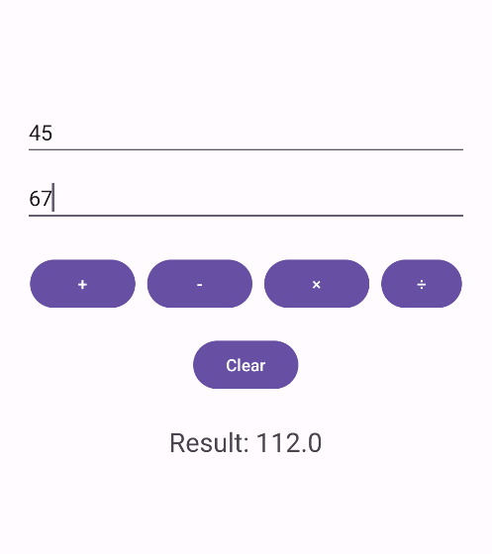

- Write a code to make phone call using Intent
activity_main.xml
<?xml version="1.0" encoding="utf-8"?>
<LinearLayout xmlns:android="http://schemas.android.com/apk/res/android"
android:layout_width="match_parent"
android:layout_height="match_parent"
android:gravity="center"
android:orientation="vertical"
android:padding="24dp"
android:background="#FFFFFF">
<Button
android:id="@+id/btnCall"
android:layout_width="wrap_content"
android:layout_height="wrap_content"
android:text="Make a Phone Call" />
</LinearLayout>
MainActivity.java
package com.example.phonecallintent;
import androidx.appcompat.app.AppCompatActivity;
import android.os.Bundle;
import android.view.View;
import android.widget.Button;
import android.content.Intent;
import android.net.Uri;
public class MainActivity extends AppCompatActivity {
Button btnCall;
@Override
protected void onCreate(Bundle savedInstanceState) {
super.onCreate(savedInstanceState);
setContentView(R.layout.activity_main);
btnCall = findViewById(R.id.btnCall);
btnCall.setOnClickListener(new View.OnClickListener() {
@Override
public void onClick(View v) {
Intent intent = new Intent(Intent.ACTION_DIAL);
intent.setData(Uri.parse("tel:9876543210"));
startActivity(intent);
}
});
}
}
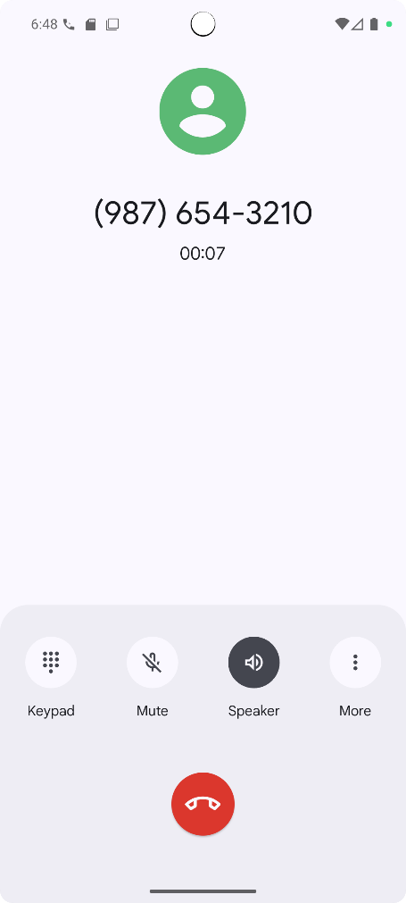

5.Write a code to turn ON/OFF Bluetooth
Activity_main.xml
<?xml version="1.0" encoding="utf-8"?>
<LinearLayout xmlns:android="http://schemas.android.com/apk/res/android"
android:layout_width="match_parent"
android:layout_height="match_parent"
android:gravity="center"
android:orientation="vertical"
android:padding="24dp">
<Button
android:id="@+id/btnOn"
android:layout_width="wrap_content"
android:layout_height="wrap_content"
android:text="Turn ON Bluetooth" />
<Button
android:id="@+id/btnOff"
android:layout_width="wrap_content"
android:layout_height="wrap_content"
android:text="Turn OFF Bluetooth"
android:layout_marginTop="20dp" />
</LinearLayout>
Java code
package com.example.m1qi;
import androidx.appcompat.app.AppCompatActivity;
import android.os.Bundle;
import android.bluetooth.BluetoothAdapter;
import android.content.Intent;
import android.view.View;
import android.widget.Button;
import android.widget.Toast;
public class MainActivity extends AppCompatActivity {Button btnOn, btnOff;
BluetoothAdapter bluetoothAdapter;
@Override
protected void onCreate(Bundle savedInstanceState) { super.onCreate(savedInstanceState);
setContentView(R.layout.activity_main);
btnOn = findViewById(R.id.btnOn);
btnOff = findViewById(R.id.btnOff);
bluetoothAdapter = BluetoothAdapter.getDefaultAdapter();
if (bluetoothAdapter == null) {
Toast.makeText(this, "Bluetooth not supported on this device", Toast.LENGTH_SHORT).show();
btnOn.setEnabled(false);
btnOff.setEnabled(false);
return; }
btnOn.setOnClickListener(new View.OnClickListener() {
@Override
public void onClick(View v) {
if (!bluetoothAdapter.isEnabled()) {
Intent enableBtIntent = new Intent(BluetoothAdapter.ACTION_REQUEST_ENABLE); startActivityForResult(enableBtIntent, 1);
Toast.makeText(MainActivity.this, "Bluetooth Turning ON...", Toast.LENGTH_SHORT).show();
} else {
Toast.makeText(MainActivity.this, "Bluetooth is already ON", Toast.LENGTH_SHORT).show(); } } });
btnOff.setOnClickListener(new View.OnClickListener() {
@Override
public void onClick(View v) {
if (bluetoothAdapter.isEnabled()) {
bluetoothAdapter.disable();
Toast.makeText(MainActivity.this, "Bluetooth Turned OFF", Toast.LENGTH_SHORT).show();
} else Toast.makeText(MainActivity.this, "Bluetooth is already OFF", Toast.LENGTH_SHORT).show(); } } }); } }
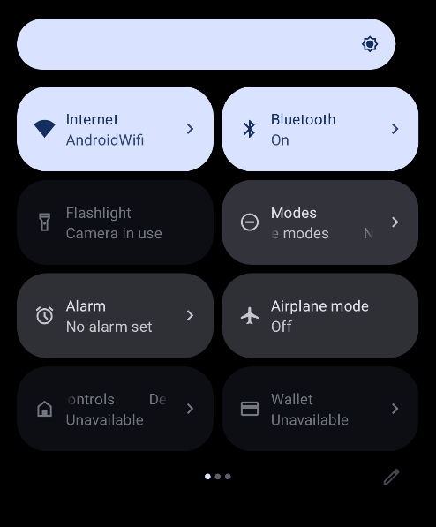

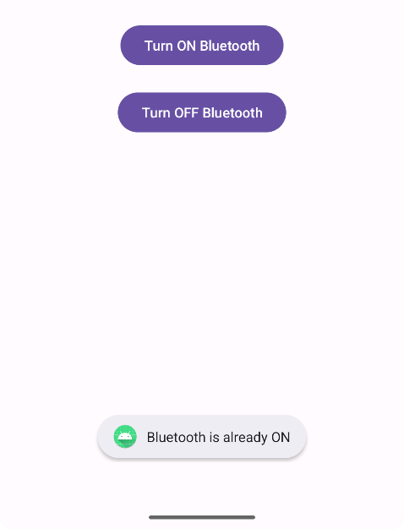

6.Write a code to turn ON /OFF the Wi-Fi
Java code:
package com.example.m1qi;
import androidx.appcompat.app.AppCompatActivity;
import android.os.Bundle;
import android.net.wifi.WifiManager;
import android.content.Context;
import android.view.View;
import android.widget.Button;
import android.widget.Toast;
public class MainActivity extends AppCompatActivity {
Button btnOn, btnOff;
WifiManager wifiManager;
@Override
protected void onCreate(Bundle savedInstanceState) {
super.onCreate(savedInstanceState);
setContentView(R.layout.activity_main);
btnOn = findViewById(R.id.btnOn);
btnOff = findViewById(R.id.btnOff);
public void onClick(View v) {
if (!wifiManager.isWifiEnabled()) {
wifiManager.setWifiEnabled(true);
Toast.makeText(MainActivity.this, "Wi-Fi Turned ON", Toast.LENGTH_SHORT).show();
} else {
Toast.makeText(MainActivity.this, "Wi-Fi is already ON", Toast.LENGTH_SHORT).show();
} } });
btnOff.setOnClickListener(new View.OnClickListener() {
@Override
public void onClick(View v) {
if (wifiManager.isWifiEnabled()) {
wifiManager.setWifiEnabled(false);
Toast.makeText(MainActivity.this, "Wi-Fi Turned OFF", Toast.LENGTH_SHORT).show();
} else {
Toast.makeText(MainActivity.this, "Wi-Fi is already OFF", Toast.LENGTH_SHORT).show();
}} }); }}
XML code:
<?xml version="1.0" encoding="utf-8"?>
<LinearLayout xmlns:android="http://schemas.android.com/apk/res/android"
android:layout_width="match_parent"
android:layout_height="match_parent"
android:orientation="vertical"
android:id="@+id/btnOn"
android:layout_width="wrap_content"
android:layout_height="wrap_content"
android:text="Turn ON Wi-Fi"
android:layout_margin="10dp" />
<Button
android:id="@+id/btnOff"
android:layout_width="wrap_content"
android:layout_height="wrap_content"
android:text="Turn OFF Wi-Fi"
android:layout_margin="10dp" />
</LinearLayout>
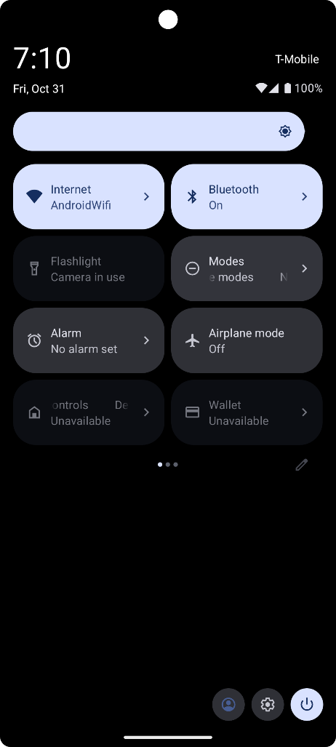

MODULE 5: Activity, Multimedia and Databases
1.Create a SIGN Upton activity with Username and Password. Validation of password should happen
Java code:
package com.example.m1qi;
import androidx.appcompat.app.AppCompatActivity;
import android.os.Bundle;
import android.view.View;
import android.widget.Button;
import android.widget.EditText;
import android.widget.Toast;
public class MainActivity extends AppCompatActivity { EditText etUsername, etPassword, etConfirmPassword;
Button btnSignup;
@Override
protected void onCreate(Bundle savedInstanceState) { super.onCreate(savedInstanceState);
setContentView(R.layout.activity_main);
etUsername = findViewById(R.id.etUsername);
etPassword = findViewById(R.id.etPassword);
etConfirmPassword = findViewById(R.id.etConfirmPassword);
btnSignup = findViewById(R.id.btnSignup);
btnSignup.setOnClickListener(new View.OnClickListener() {
@Override
public void onClick(View v) {
String username = etUsername.getText().toString().trim();
String password = etPassword.getText().toString().trim();
String confirmPassword = etConfirmPassword.getText().toString().trim();
if (username.isEmpty() || password.isEmpty() || confirmPassword.isEmpty()) {
Toast.makeText(MainActivity.this, "Please fill all fields!", Toast.LENGTH_SHORT).show();
} else if (!password.equals(confirmPassword)) {
Toast.makeText(MainActivity.this, "Passwords do not match!", Toast.LENGTH_SHORT).show();
} else if (password.length() < 6) {
Toast.makeText(MainActivity.this, "Password must be at least 6 characters long!", Toast.LENGTH_SHORT).show();
} else {
Toast.makeText(MainActivity.this, "Sign Up Successful!", Toast.LENGTH_SHORT).show();
}} }); } }
XML code:
<?xml version="1.0" encoding="utf-8"?>
<LinearLayout xmlns:android="http://schemas.android.com/apk/res/android"
android:layout_width="match_parent"
android:layout_height="match_parent"
android:orientation="vertical"
android:gravity="center"
android:padding="24dp"
android:background="#FFF8E1">
<TextView
android:layout_width="wrap_content"
android:layout_height="wrap_content"
android:text="Sign Up Form"
android:textStyle="bold"
android:textSize="22sp"
android:layout_marginBottom="20dp" />
<EditText
android:id="@+id/etUsername"
android:layout_width="match_parent"
android:layout_height="wrap_content"
android:hint="Enter Username"
android:inputType="textPersonName"
android:layout_marginBottom="12dp" />
<EditText
android:id="@+id/etPassword"
android:layout_width="match_parent"
android:layout_height="wrap_content"
android:hint="Enter Password"
android:inputType="textPassword"
android:layout_marginBottom="12dp" />
<EditText
android:id="@+id/etConfirmPassword"
android:layout_width="match_parent"
android:layout_height="wrap_content"
android:hint="Confirm Password"
android:inputType="textPassword"
android:layout_marginBottom="16dp" />
<Button
android:id="@+id/btnSignup"
android:layout_width="match_parent"
android:layout_height="wrap_content"
android:text="Sign Up"
android:backgroundTint="#FFB300"
android:textColor="#FFFFFF" />
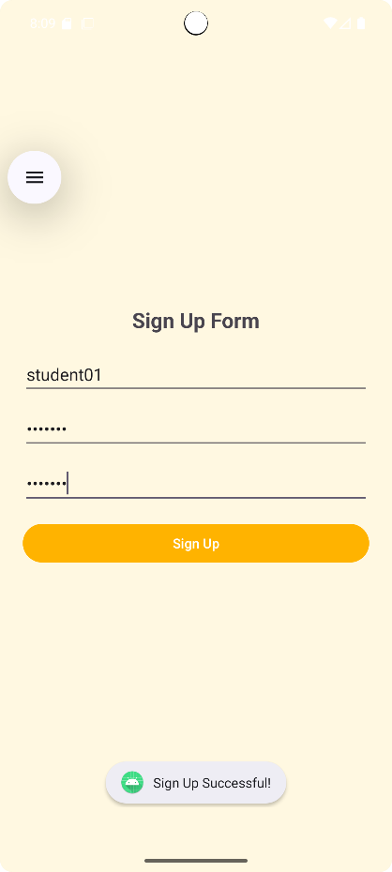
</LinearLayout>

2. Create a SIGN-Up activity with Username and Password. Validation of password should happen based on the following rules: - Password should contain uppercase and lowercase letters. - Password should contain letters and numbers. - Password should contain special characters. - Minimum length of the password (the default value is 8). On successful SIGN UP proceed to the next Login activity. Here the user should SIGN IN using the Username and Password created during signup activity. If the Username and Password are matched then navigate to the next activity which displays a message saying “Successful Login” or else display a toast message saying “Login Failed”. The user is given only two attempts and after that display a toast message saying “Failed Login Attempts” and disable the SIGN IN button. Use Bundle to transfer information from one activity to another.
Activity_sign_up.xml
<?xml version="1.0" encoding="utf-8"?>
<LinearLayout xmlns:android="http://schemas.android.com/apk/res/android"
android:layout_width="match_parent"
android:layout_height="match_parent"
android:orientation="vertical"
android:padding="24dp"
android:gravity="center"
android:background="#FAFAFA">
<TextView
android:layout_width="wrap_content"
android:layout_height="wrap_content"
android:text="Sign Up"
android:textSize="24sp"
android:textStyle="bold"
android:layout_marginBottom="24dp"
android:textColor="#000000" />
<EditText
android:id="@+id/etUsername"
android:layout_width="match_parent"
android:layout_height="wrap_content"
android:hint="Enter Username"
android:inputType="textPersonName"
android:layout_marginBottom="16dp" />
<EditText
android:id="@+id/etPassword"
android:layout_width="match_parent"
android:layout_height="wrap_content"
android:hint="Enter Password"
android:inputType="textPassword"
android:layout_marginBottom="16dp" />
<EditText
android:id="@+id/etConfirmPassword"
android:layout_width="match_parent"
android:layout_height="wrap_content"
android:hint="Confirm Password"
android:inputType="textPassword"
android:layout_marginBottom="24dp" />
<Button
android:id="@+id/btnSignUp"
android:layout_width="match_parent"
android:layout_height="wrap_content"
android:text="Sign Up" />
</LinearLayout>
Activity_login.xml
<?xml version="1.0" encoding="utf-8"?>
<LinearLayout xmlns:android="http://schemas.android.com/apk/res/android"
android:layout_width="match_parent"
android:layout_height="match_parent"
android:orientation="vertical"
android:padding="24dp"
android:gravity="center"
android:background="#FAFAFA">
<TextView
android:layout_width="wrap_content"
android:layout_height="wrap_content"
android:text="LOGIN"
android:textSize="24sp"
android:textStyle="bold"
android:layout_marginBottom="24dp"
android:textColor="#000000" />
<EditText
android:id="@+id/etLoginUsername"
android:layout_width="match_parent"
android:layout_height="wrap_content"
android:hint="Enter Username"
android:inputType="textPersonName"
android:layout_marginBottom="16dp" />
<EditText
android:id="@+id/etLoginPassword"
android:layout_width="match_parent"
android:layout_height="wrap_content"
android:hint="Enter Password"
android:inputType="textPassword"
android:layout_marginBottom="16dp" />
<Button
android:id="@+id/btnLogin"
android:layout_width="match_parent"
android:layout_height="wrap_content"
android:text="LOGIN" />
</LinearLayout>

Activity_success.xml
<?xml version="1.0" encoding="utf-8"?>
<LinearLayout xmlns:android="http://schemas.android.com/apk/res/android"
android:orientation="vertical"
android:gravity="center"
android:background="#C8E6C9"
android:layout_width="match_parent"
android:layout_height="match_parent">
<TextView
android:text="🎉 Successful Login 🎉"
android:textSize="24sp"
android:textStyle="bold"
android:textColor="#2E7D32" />
</LinearLayout>

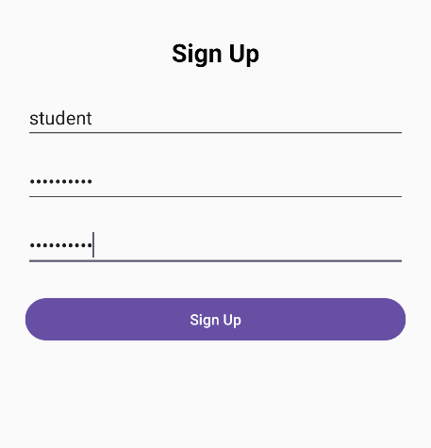

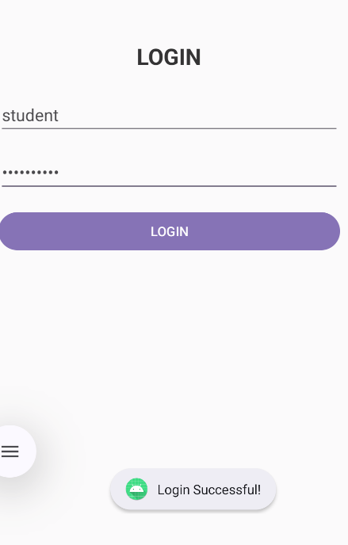

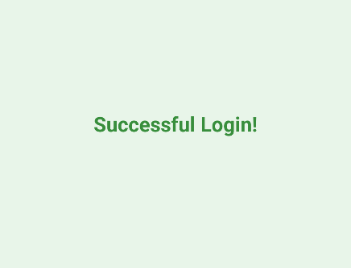

3. Create an application that will create database to store username and password
DatabaseHelper.java
package com.example.m1qi;
import android.content.Context;
import android.database.sqlite.SQLiteDatabase;
import android.database.sqlite.SQLiteOpenHelper;
import android.content.ContentValues;
import android.database.Cursor;
public class DatabaseHelper extends SQLiteOpenHelper {
public static final String DATABASE_NAME = "UserDB.db";
public static final String TABLE_NAME = "users";
public static final String COL_1 = "ID";
public static final String COL_2 = "USERNAME";
public static final String COL_3 = "PASSWORD";
public DatabaseHelper(Context context) {
super(context, DATABASE_NAME, null, 1);
}@Override
public void onCreate(SQLiteDatabase db) {
db.execSQL("CREATE TABLE " + TABLE_NAME + " (ID INTEGER PRIMARY KEY AUTOINCREMENT, USERNAME TEXT, PASSWORD TEXT)");
} @Override
public void onUpgrade(SQLiteDatabase db, int oldVersion, int newVersion) {
db.execSQL("DROP TABLE IF EXISTS " + TABLE_NAME);
onCreate(db);
} public boolean insertData(String username, String password) {
SQLiteDatabase db = this.getWritableDatabase();
ContentValues contentValues = new ContentValues();
contentValues.put(COL_2, username);
contentValues.put(COL_3, password);
long result = db.insert(TABLE_NAME, null, contentValues);
return result != -1;
} public boolean checkUser(String username, String password) {
SQLiteDatabase db = this.getReadableDatabase();
Cursor cursor = db.rawQuery("SELECT * FROM " + TABLE_NAME + " WHERE USERNAME=? AND PASSWORD=?", new String[]{username, password});
return cursor.getCount() > 0;
} }
SignUpActivity.java
package com.example.m1qi;
import androidx.appcompat.app.AppCompatActivity;
import android.os.Bundle;
import android.widget.Button;
import android.widget.EditText;
import android.widget.Toast;
import android.content.Intent;
public class SignUpActivity extends AppCompatActivity {
EditText etUsername, etPassword, etConfirmPassword;
Button btnSignUp;
DatabaseHelper db;
@Override
protected void onCreate(Bundle savedInstanceState) {super.onCreate(savedInstanceState);
setContentView(R.layout.activity_sign_up);
etUsername = findViewById(R.id.etUsername);
etPassword = findViewById(R.id.etPassword);
etConfirmPassword = findViewById(R.id.etConfirmPassword);
btnSignUp = findViewById(R.id.btnSignUp);
db = new DatabaseHelper(this);
btnSignUp.setOnClickListener(v -> {
String user = etUsername.getText().toString();
String pass = etPassword.getText().toString();
String confirm = etConfirmPassword.getText().toString();
if (user.isEmpty() || pass.isEmpty() || confirm.isEmpty()) {
Toast.makeText(this, "Please fill all fields", Toast.LENGTH_SHORT).show();
} else if (!pass.equals(confirm)) {
Toast.makeText(this, "Passwords do not match", Toast.LENGTH_SHORT).show();
} else {
boolean inserted = db.insertData(user, pass);
if (inserted) {
Toast.makeText(this, "Sign Up Successful!", Toast.LENGTH_SHORT).show();
startActivity(new Intent(this, LoginActivity.class));
} else {
Toast.makeText(this, "Error! Try again.", Toast.LENGTH_SHORT).show();
} } }); } }
LoginActivity.java
package com.example.m1qi;
import androidx.appcompat.app.AppCompatActivity;
import android.os.Bundle;
import android.widget.Button;
import android.widget.EditText;
import android.widget.Toast;
import android.content.Intent;
public class LoginActivity extends AppCompatActivity {
EditText etLoginUsername, etLoginPassword;
Button btnLogin, btnGotoSignup;
DatabaseHelper db;
@Override
protected void onCreate(Bundle savedInstanceState) {super.onCreate(savedInstanceState);
setContentView(R.layout.activity_login);
etLoginUsername = findViewById(R.id.etLoginUsername);
etLoginPassword = findViewById(R.id.etLoginPassword);
btnLogin = findViewById(R.id.btnLogin);
btnGotoSignup = findViewById(R.id.btnGotoSignup);
db = new DatabaseHelper(this);
btnLogin.setOnClickListener(v -> {
String user = etLoginUsername.getText().toString();
String pass = etLoginPassword.getText().toString();
if (db.checkUser(user, pass)) {
Toast.makeText(this, "Login Successful!", Toast.LENGTH_SHORT).show();
startActivity(new Intent(this, SuccessActivity.class));
} else {
Toast.makeText(this, "Invalid Credentials!", Toast.LENGTH_SHORT).show();
} }); btnGotoSignup.setOnClickListener(v -> { startActivity(new Intent(this, SignUpActivity.class));
}); }}
SuccessActivity.java
package com.example.m1qi;
import androidx.appcompat.app.AppCompatActivity;
import android.os.Bundle;
import android.widget.TextView;
public class SuccessActivity extends AppCompatActivity {
@Override
protected void onCreate(Bundle savedInstanceState) {
super.onCreate(savedInstanceState);
setContentView(R.layout.activity_success);
TextView textView = findViewById(R.id.tvSuccess);
textView.setText("Welcome! Login Successful ✅");
}
}

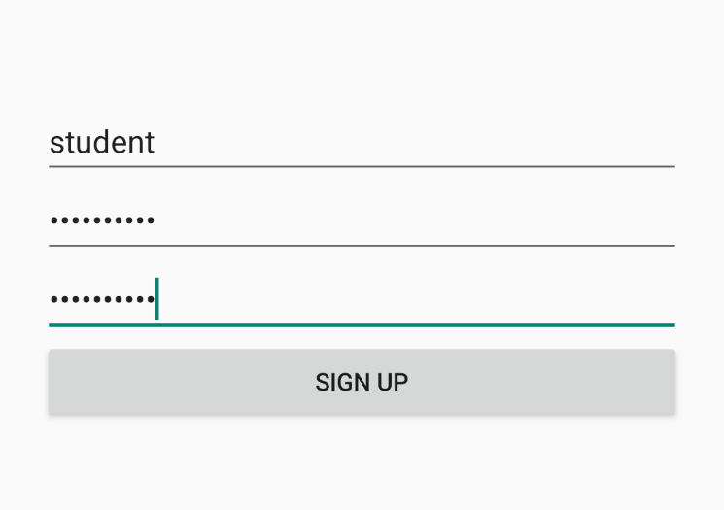
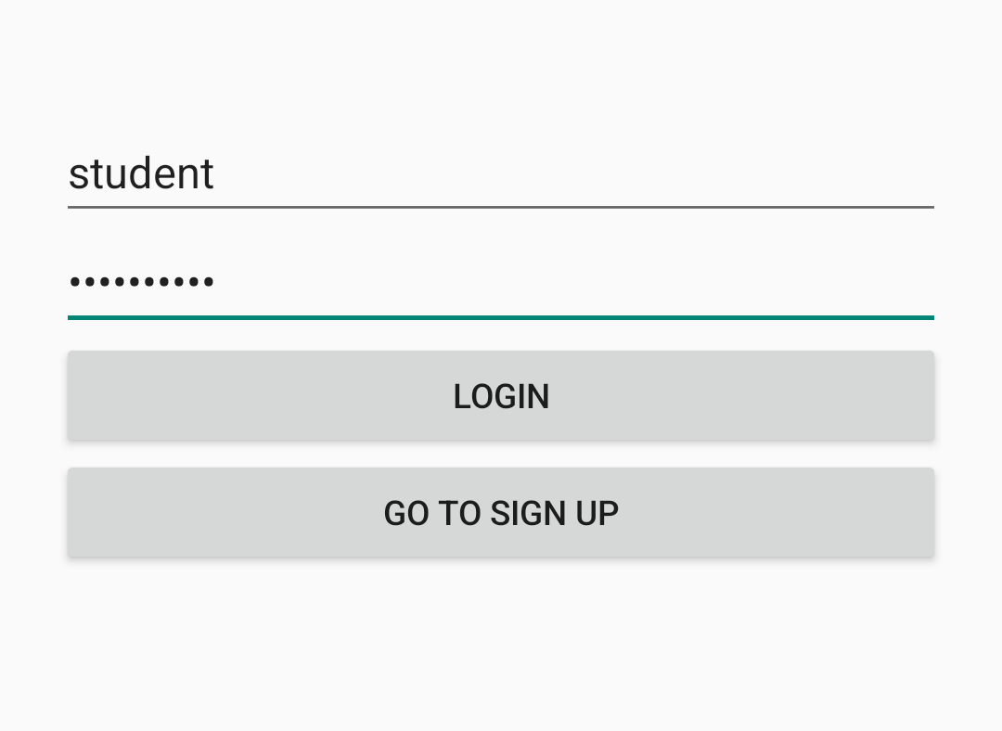
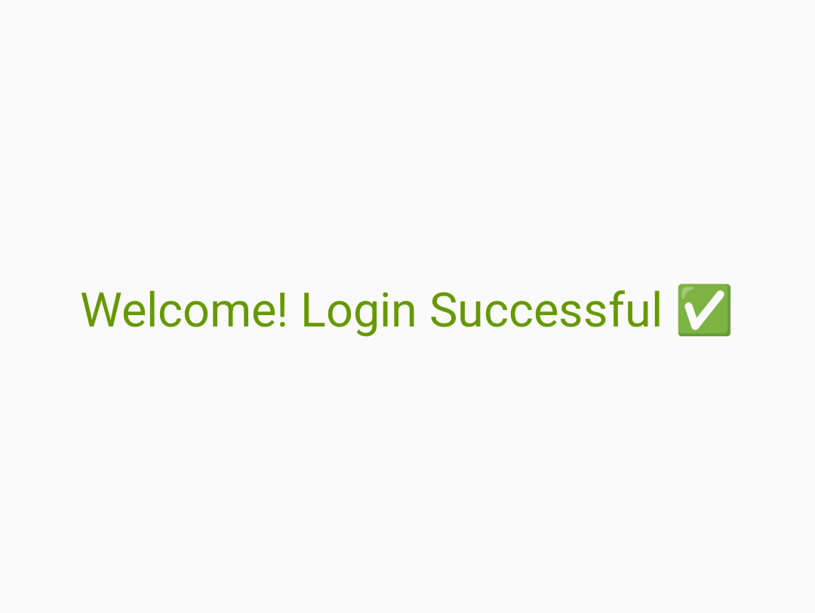

4. Create an application to change screen colour as per the user choice from a menu
Activity_main.xml
<?xml version="1.0" encoding="utf-8"?>
<RelativeLayout xmlns:android="http://schemas.android.com/apk/res/android"
android:id="@+id/layoutMain"
android:layout_width="match_parent"
android:layout_height="match_parent"
android:background="#FFFFFF">
<TextView
android:id="@+id/tvMessage"
android:layout_width="wrap_content"
android:layout_height="wrap_content"
android:text="Choose a Color from Menu"
android:textSize="20sp"
android:textStyle="bold"
android:layout_centerInParent="true"
android:textColor="#000000"/>
</RelativeLayout>
Menu_colors.xml
<?xml version="1.0" encoding="utf-8"?>
<menu xmlns:android="http://schemas.android.com/apk/res/android">
<item
android:id="@+id/red"
android:title="Red"/>
<item
android:id="@+id/green"
android:title="Green"/>
<item
android:id="@+id/blue"
android:title="Blue"/>
</menu>

MainActivity.java
package com.example.m1qi;
import androidx.appcompat.app.AppCompatActivity;
import android.os.Bundle;
import android.view.Menu;
import android.view.MenuInflater;
import android.view.MenuItem;
import android.widget.RelativeLayout;

public class MainActivity extends AppCompatActivity {
RelativeLayout layoutMain;
@Override
protected void onCreate(Bundle savedInstanceState) {
super.onCreate(savedInstanceState);
setContentView(R.layout.activity_main);

layoutMain = findViewById(R.id.layoutMain);
}
@Override
public boolean onCreateOptionsMenu(Menu menu) {
MenuInflater inflater = getMenuInflater();
inflater.inflate(R.menu.menu_colors, menu);
return true;
}
@Override
public boolean onOptionsItemSelected(MenuItem item) {
switch (item.getItemId()) {
case R.id.red: layoutMain.setBackgroundColor(getResources().getColor(android.R.color.holo_red_light));
return true;
case R.id.green:
layoutMain.setBackgroundColor(getResources().getColor(android.R.color.holo_green_light));
return true;
case R.id.blue: layoutMain.setBackgroundColor(getResources().getColor(android.R.color.holo_blue_light));
return true;
default:
return super.onOptionsItemSelected(item);
}
}
}

<?xml version="1.0" encoding="utf-8"?>
<manifest xmlns:android="http://schemas.android.com/apk/res/android"
package="com.example.m1qi">
<application
android:allowBackup="true"
android:icon="@mipmap/ic_launcher"
android:label="Color Menu App"
android:roundIcon="@mipmap/ic_launcher_round"
android:supportsRtl="true"
android:theme="@style/Theme.AppCompat.Light.NoActionBar">

<activity android:name=".MainActivity">
<intent-filter>
<action android:name="android.intent.action.MAIN" />
<category android:name="android.intent.category.LAUNCHER" />
</intent-filter>
</activity>

</application>
</manifest>
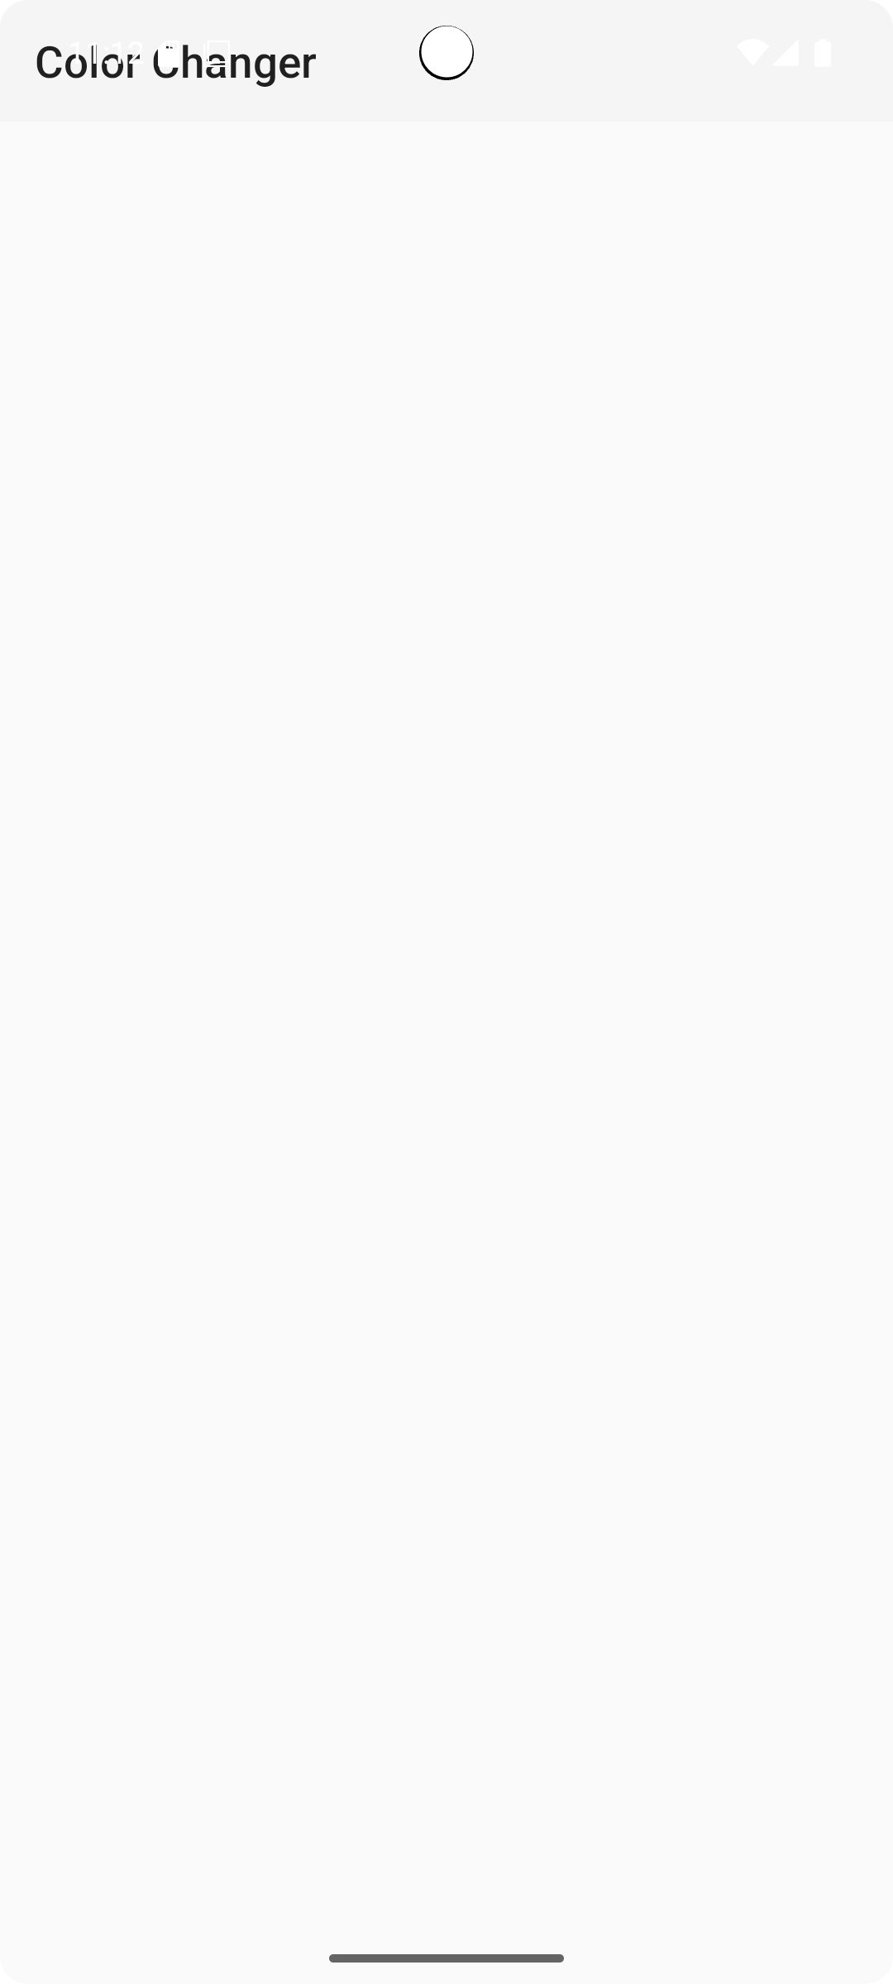

5.Develop a simple application with one Edit Text so that the user can write some text in it. Create a button called “Convert Text to Speech” that converts the user input text into voice
package com.example.m1qi;
import androidx.appcompat.app.AppCompatActivity;
import android.os.Bundle;
import android.speech.tts.TextToSpeech;
import android.widget.Button;
import android.widget.EditText;
import android.widget.Toast;
import java.util.Locale;
public class MainActivity extends AppCompatActivity { EditText editTextInput;
Button btnSpeak;
TextToSpeech tts;
@Override
protected void onCreate(Bundle savedInstanceState) {super.onCreate(savedInstanceState);
setContentView(R.layout.activity_main);
editTextInput = findViewById(R.id.editTextInput);
btnSpeak = findViewById(R.id.btnSpeak);
tts = new TextToSpeech(this, status -> {
if (status == TextToSpeech.SUCCESS) {
int result = tts.setLanguage(Locale.US);
if (result == TextToSpeech.LANG_MISSING_DATA ||
result == TextToSpeech.LANG_NOT_SUPPORTED) {
Toast.makeText(this, "Language not supported", Toast.LENGTH_SHORT).show();
} } else {
Toast.makeText(this, "TTS Initialization failed", Toast.LENGTH_SHORT).show();
} });
btnSpeak.setOnClickListener(v -> {
String text = editTextInput.getText().toString().trim();
if (text.isEmpty()) {
Toast.makeText(this, "Please enter some text", Toast.LENGTH_SHORT).show();
} else {
tts.speak(text, TextToSpeech.QUEUE_FLUSH, null, null);
} }); }
@Override
protected void onDestroy() {
if (tts != null) {
tts.stop();
tts.shutdown();
} super.onDestroy(); } }
Mainactivity.xml
<?xml version="1.0" encoding="utf-8"?>
<LinearLayout xmlns:android="http://schemas.android.com/apk/res/android"
android:layout_width="match_parent"
android:layout_height="match_parent"
android:orientation="vertical"
android:gravity="center"
android:padding="20dp"
android:background="#FAFAFA">
<EditText
android:id="@+id/editTextInput"
android:layout_width="match_parent"
android:layout_height="wrap_content"
android:hint="Enter text here"
android:textSize="18sp"
android:padding="10dp"
android:background="@android:drawable/edit_text"
android:inputType="text" />
<Button
android:id="@+id/btnSpeak"
android:layout_width="wrap_content"
android:layout_height="wrap_content"
android:text="Convert Text to Speech"
android:layout_marginTop="20dp"
android:padding="10dp" />
</LinearLayout>

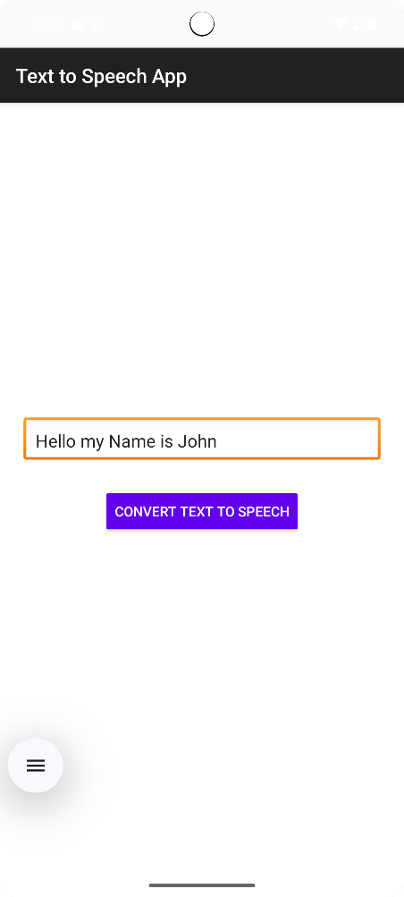

6.Write an application using SQLite to create table and perform CRUD operations (Example. COURSE table (ID, Name, Duration, Description), perform ADD, UPDATE, DELETE and READ operations)
DBHelper.java
package com.example.m1qi;
import android.content.ContentValues;
import android.content.Context;
import android.database.Cursor;
import android.database.sqlite.SQLiteDatabase;
import android.database.sqlite.SQLiteOpenHelper;
public class DBHelper extends SQLiteOpenHelper {
private static final String DB_NAME = "courses.db";
private static final int DB_VERSION = 1;
private static final String TABLE_NAME = "COURSE";
private static final String ID_COL = "ID";
private static final String NAME_COL = "NAME";
private static final String DURATION_COL = "DURATION";
private static final String DESC_COL = "DESCRIPTION";
public DBHelper(Context context) {
super(context, DB_NAME, null, DB_VERSION);
}
@Override
public void onCreate(SQLiteDatabase db) {
String query = "CREATE TABLE " + TABLE_NAME + " ("
+ ID_COL + " INTEGER PRIMARY KEY AUTOINCREMENT, "
+ NAME_COL + " TEXT, "
+ DURATION_COL + " TEXT, "
+ DESC_COL + " TEXT)";
db.execSQL(query);
}@Override
public void onUpgrade(SQLiteDatabase db, int oldVersion, int newVersion) {
values.put(DESC_COL, description);
db.insert(TABLE_NAME, null, values);
db.close();
} public void updateCourse(int id, String name, String duration, String description) {
SQLiteDatabase db = this.getWritableDatabase();
ContentValues values = new ContentValues();
values.put(NAME_COL, name);
String[]{String.valueOf(id)});
db.close(); } public Cursor getAllCourses() {
SQLiteDatabase db = this.getReadableDatabase();
return db.rawQuery("SELECT * FROM " + TABLE_NAME, null);
}}
mainactivity.java
package com.example.m1qi;
import androidx.appcompat.app.AppCompatActivity;
import android.database.Cursor;
import android.os.Bundle;
import android.widget.Button;
import android.widget.EditText;
import android.widget.TextView;
import android.widget.Toast;
public class MainActivity extends AppCompatActivity { EditText etId, etName, etDuration, etDesc;
Button btnAdd, btnUpdate, btnDelete, btnView;
TextView tvResult;
DBHelper dbHelper;
@Override
protected void onCreate(Bundle savedInstanceState) {super.onCreate(savedInstanceState);
Toast.LENGTH_SHORT).show();
});
btnUpdate.setOnClickListener(v -> { dbHelper.updateCourse(Integer.parseInt(etId.getText().toString()),
etName.getText().toString(),
etDuration.getText().toString(),
etDesc.getText().toString());
Toast.makeText(this, "Course Updated", Toast.LENGTH_SHORT).show();
});
btnDelete.setOnClickListener(v -> { dbHelper.deleteCourse(Integer.parseInt(etId.getText().toString()));
Toast.makeText(this, "Course Deleted", Toast.LENGTH_SHORT).show();
}); btnView.setOnClickListener(v -> {
Cursor cursor = dbHelper.getAllCourses();
StringBuilder sb = new StringBuilder();
while (cursor.moveToNext()) {
sb.append("ID: ").append(cursor.getInt(0)).append("\n");
sb.append("Name: ").append(cursor.getString(1)).append("\n");
sb.append("Duration: ").append(cursor.getString(2)).append("\n");
sb.append("Description: ").append(cursor.getString(3)).append("\n\n");
}
tvResult.setText(sb.toString());
});}}
activity_main.xml
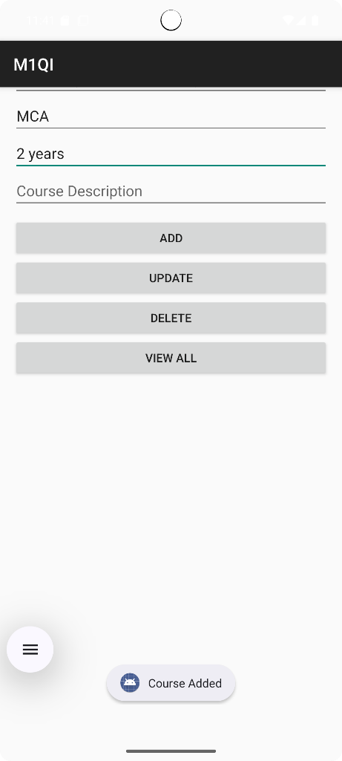
<?xml version="1.0" encoding="utf-8"?>
<ScrollView xmlns:android="http://schemas.android.com/apk/res/android"
android:layout_width="match_parent"
android:layout_height="match_parent"
android:padding="16dp">
<LinearLayout
android:orientation="vertical"
android:layout_width="match_parent"
android:layout_height="wrap_content">
<EditText
android:id="@+id/etId"
android:layout_width="match_parent"
android:layout_height="wrap_content"
android:hint="Enter ID (for Update/Delete)"
android:inputType="number" />
<EditText
android:id="@+id/etName"
android:layout_width="match_parent"
android:layout_height="wrap_content"
android:hint="Course Name" />
<EditText
android:id="@+id/etDuration"
android:layout_width="match_parent"
android:layout_height="wrap_content"
android:hint="Course Duration" />
<EditText
android:id="@+id/etDesc"
android:layout_width="match_parent"
android:layout_height="wrap_content"
android:hint="Course Description" />
<Button
android:id="@+id/btnAdd"
android:text="ADD"
android:layout_width="match_parent"
android:layout_height="wrap_content"
android:layout_marginTop="10dp" />
<Button
android:id="@+id/btnUpdate"
android:text="UPDATE"
android:layout_width="match_parent"
android:layout_height="wrap_content" />
<Button
android:id="@+id/btnDelete"
android:text="DELETE"
android:layout_width="match_parent"
android:layout_height="wrap_content" />
<Button
android:id="@+id/btnView"
android:text="VIEW ALL"
android:layout_width="match_parent"
android:layout_height="wrap_content" />
<TextView
android:id="@+id/tvResult"
android:layout_width="match_parent"
android:layout_height="wrap_content"
android:textSize="16sp"
android:paddingTop="20dp" />
</LinearLayout>
</ScrollView>

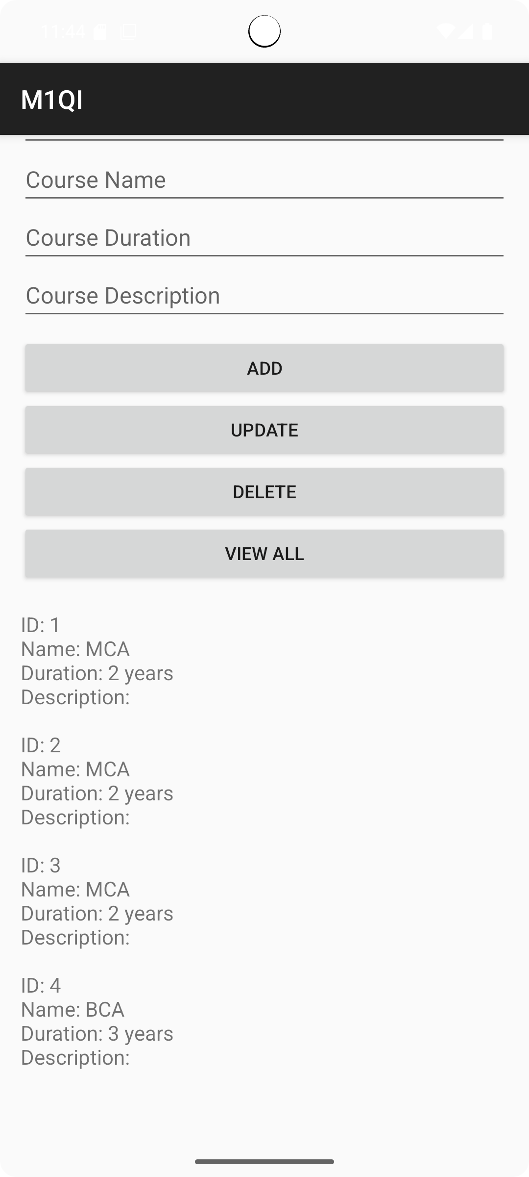

MODULE 6: Introduction to Flutter
1.Develop simple flutter application to open a browser.
pubspec.yaml
dependencies:
flutter:
sdk: flutter
cupertino_icons: ^1.0.2
url_launcher: ^6.3.0
lib/main.dart
import 'package:flutter/material.dart';
import 'package:url_launcher/url_launcher.dart';
void main() {
runApp(const MyApp());
}class MyApp extends StatelessWidget {
const MyApp({super.key});
final String _urlString = 'https://www.google.com';
Future<void> _openBrowser() async {
final Uri url = Uri.parse(_urlString);
browser
if (!await launchUrl(url, mode: LaunchMode.externalApplication)) {
debugPrint('Could not launch $url');
} } @override
Widget build(BuildContext context) {
return MaterialApp(
title: 'Open Browser Example',
debugShowCheckedModeBanner: false,
home: Scaffold(
appBar: AppBar(
title: const Text('Open Browser Example'),
), body: Center(
child: ElevatedButton.icon(
onPressed: _openBrowser,
icon: const Icon(Icons.open_in_browser),
label: const Text('Open Browser'),
style: ElevatedButton.styleFrom(padding: const EdgeInsets.all(14)), ), ), ), ); } }

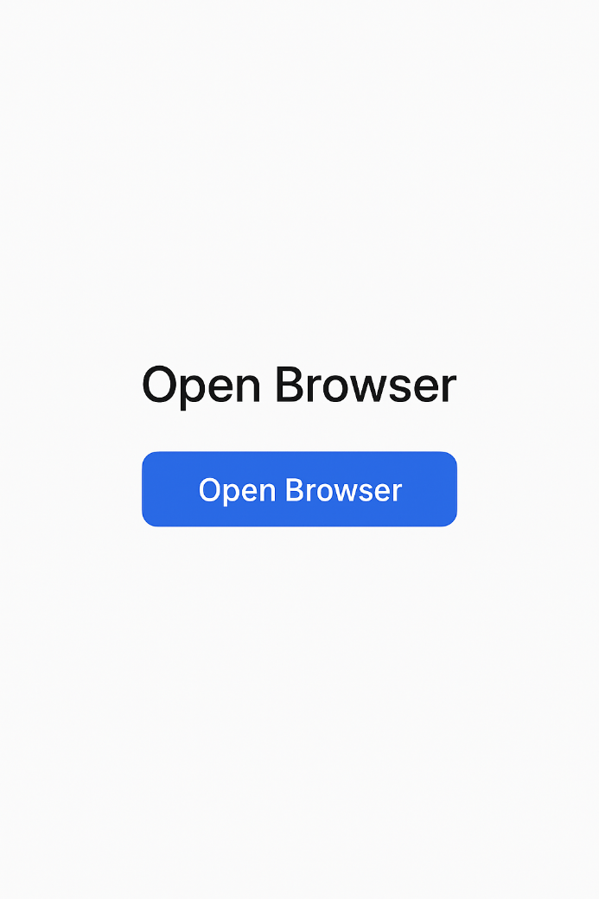

2.Create a basic Flutter app that displays "Hello Flutter!" at the center of the screen using a Text widget. Customize the text with styling like color, size, and font weight.
import 'package:flutter/material.dart';
void main() {
runApp(const MyApp());
}
class MyApp extends StatelessWidget {
const MyApp({super.key});
@override
Widget build(BuildContext context) {
return MaterialApp(
debugShowCheckedModeBanner: false,
title: 'Hello Flutter App',
home: Scaffold(
appBar: AppBar(
title: const Text('Hello Flutter App'),
backgroundColor: Colors.blueAccent,
),
body: const Center(
child: Text(
'Hello Flutter!',
style: TextStyle(
fontSize: 30,
color: Colors.purple,
fontWeight: FontWeight.bold,
fontStyle: FontStyle.italic,
letterSpacing: 2.0,
), ), ), ), );} }

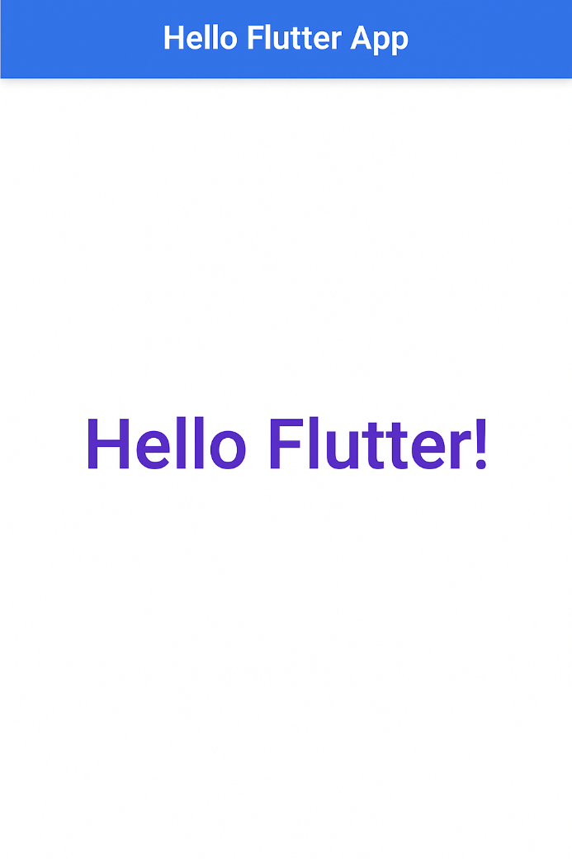

3.Create a user interface with the following: • AppBar • A Column with 3 different widgets (e.g., Image, Text, Button) • Each widget should demonstrate the widget tree concept.
Code:- main.dart
import 'package:flutter/material.dart';
void main() => runApp(WidgetTreeApp());
class WidgetTreeApp extends StatelessWidget {
@override
Widget build(BuildContext context)
{
return MaterialApp(
home: Scaffold(
appBar: AppBar(
title: Text('Widget Tree Example'),
backgroundColor: Colors.deepPurple, ),
32 body:
Column(
mainAxisAlignment: MainAxisAlignment.center,
children: [
Image.network(
'https://flutter.dev/images/flutter-logo-sharing.png', height: 100,
),
Text(
'Welcome to Flutter!',
style: TextStyle(fontSize: 24, color: Colors.black87),
),
ElevatedButton(
onPressed: () {},
child: Text('Click Me'),
),],),),);
}}

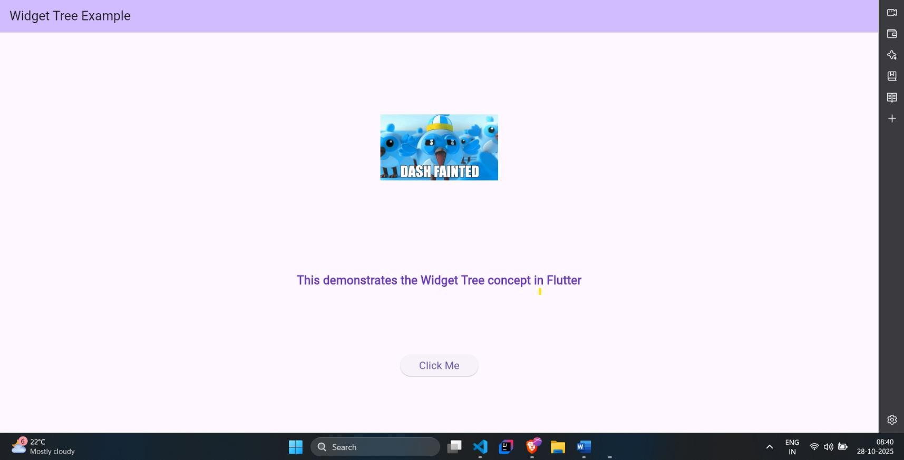

- Write a Dart program (not in Flutter) to:
• Accept a list of integers from the user
• Sort the list
• Display the sorted list and calculate the average

Code:- main.dart

import 'dart:io';

void main() {

stdout.write('Enter integers separated by space: ');

List numbers = stdin.readLineSync()!

.split(' ')

.map((e) => int.parse(e))

.toList();

numbers.sort();

double avg = numbers.reduce((a, b) => a + b) / numbers.length;

print('\nSorted List: $numbers');

print('Average: ${avg.toStringAsFixed(2)}');

}

- Develop a Flutter app that increments a counter each time a button is pressed. Display the current count using a Text widget. Use a StatefulWidget to manage state.

Code:- main.dart

import 'package:flutter/material.dart';

void main() => runApp(CounterApp());

class CounterApp extends StatelessWidget {

@override

Widget build(BuildContext context) {

return MaterialApp(

home: CounterScreen(),

);
}
}

class CounterScreen extends StatefulWidget { @override

CounterScreenState createState() => _CounterScreenState();

}

class _CounterScreenState extends State {

int count = 0;

void increment() {

setState(() {

count++;

}); }

@override

Widget build(BuildContext context) {

return Scaffold(

appBar: AppBar(title: Text('Counter App')),

body: Center(

child: Text(

'Count: $count',
style: TextStyle(fontSize: 30),
),
),

floatingActionButton: FloatingActionButton(

onPressed: increment,

child: Icon(Icons.add),

),);}}

